Dear Parents/Carers
Welcome to our weekly newsletter.
Curriculum news

Maths morning
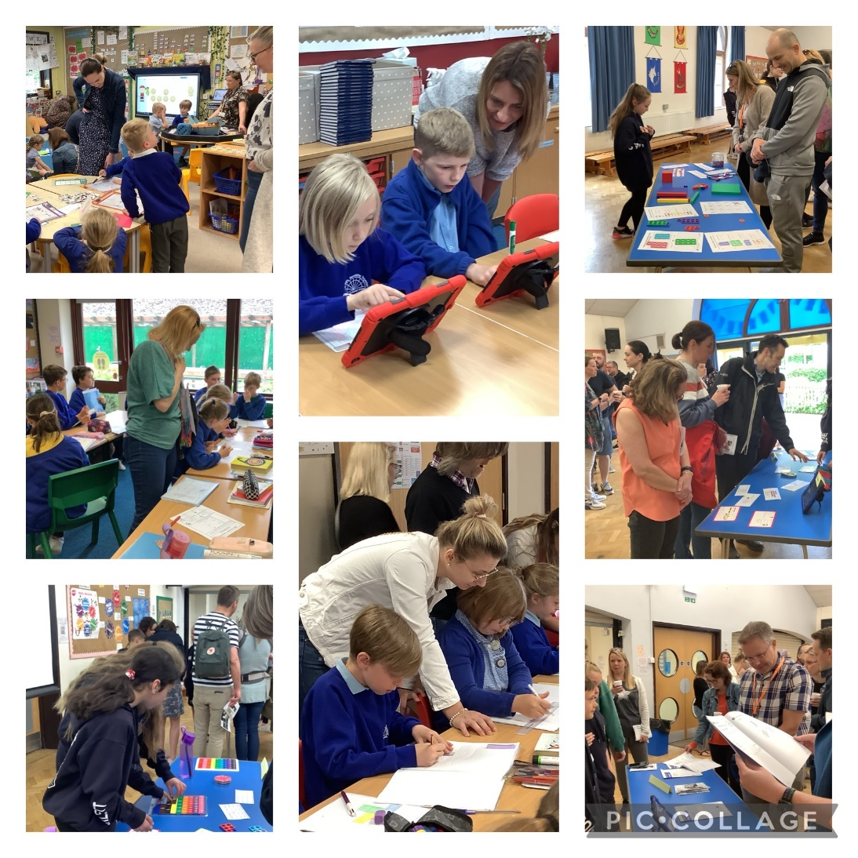
It was lovely to see so many parents in school this morning for our Maths morning. The year 6 children enjoyed demonstrating different maths techniques from across all year groups in the hall, talking about how maths develops throughout the school. In the classrooms, the children were very keen to share their learning with all our visitors, showing different maths concepts including; fractions, co-ordinates, money and time.
Thank you for those of you who joined us, we hope you found it informative.
If you would like to find out any more about maths in school, please visit our maths page on the school website to find out more.



Alternative Sports
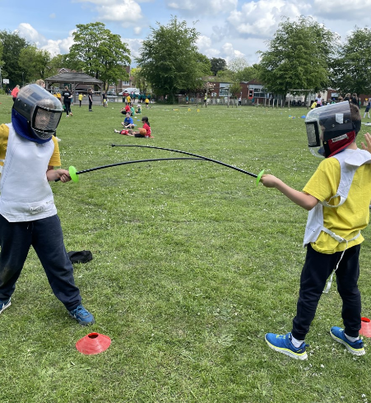
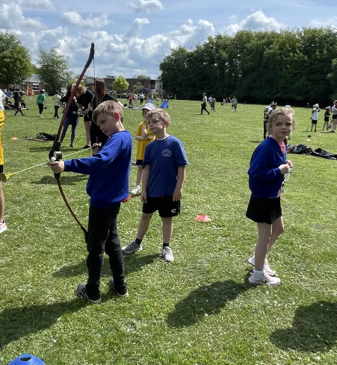
On Wednesday, 8 KS2 children went to an Alternative Sports festival at Kingslea School. The sun was shining and the children worked around the carousel of activities which included archery, pop lacrosse, ultimate frisbee and fencing. It was a great experience for all involved and it was lovely to see our pupils working so well with children from other schools too. Mrs E Wright

Safeguarding
As part of our safeguarding measures, we practice safety drills to ensure that children and staff know what to do in the event of a fire or other emergency situations. A practice also helps us to know that our procedures on paper work practically and whether there is anything we need to amend in the future.
Earlier this week, we practised a partial lockdown drill and each classroom closed their doors and pulled window blinds down before continuing with their learning. After a couple of minutes the ‘all clear’ message was relayed and the drill was over. The children were praised for their positive reactions and the process went smoothly for all concerned.

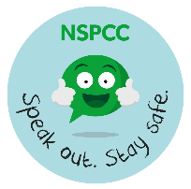
On Monday we held a ‘Speak out, Stay safe’ assembly based on NSPCC materials, which reinforced the message for children to talk to a trusted adult if they are worried or anxious about anything. Another resource to help young children aged 3+ in difficult situations to seek support is a downloadable story, Hanni and the Magic Window from ChildNet. Their objective is to make them aware of how to seek help. By following the link below you can also find simplified resources around the story, as well as the story itself. https://www.childnet.com/resources/hanni-and-the-magic-window/
Picture News
This week’s topic for discussion is ‘Should all animals be treated equally?’ – see below.



Hot Meals Ordering Cut off dates-
June Cut off Dates | July Cut off Dates
Thursday 1/6 for w/c Mon12/6 | Thursday 6/7 for w/c Monday 17/7
Thursday 8/6 for w/c Mon 19/6
Thursday 15/6 for w/c Mon 26/6 | August Cut off Dates TBC
Thursday 22/6 for w/c Mon 3/7 | Thursday 24/8 for w/c Monday 4/9
Thursday 29/6 for w/c Mon 10/7

Diary dates (new dates will appear in bold)
SUMMER TERM
Monday 22nd May | NSPCC workshops for Year 5 & 6
Wednesday 24th May | Class Photographs
Friday 26th May | INSET Day – school closed
Monday 29th May-Friday 2nd June | HALF TERM
Monday 5th June | Y6 Bikeability
Thursday 8th June | Sayers Croft meeting for Y4 parents
Tuesday 20th June | Anti-Bullying Ambassadors training
Wednesday 28th June | Sports Day
Friday 30th June | Y2 trip to Drusillas
Saturday 1st July | FOH Summer Fayre
Monday 3rd – Weds 5th July | Y4 Sayers Croft trip
Wednesday 5th July | Y6 transition day to secondary schools
Tuesday 11th July | Y6 Play 7pm
Wednesday 12th July | Y6 Play 7pm
Wednesday 12th July | Reception trip to Washbrook Farm
Thursday 13th July | Open Afternoon
Friday 14th July | Y6 Picnic
Monday 17th July | Y6 Leavers Assembly
Tuesday 18th July | Y6 BBQ

Have a lovely weekend.
Kind regards,

Ian Holmes
Headteacher

